**Ebook Management Store Documentation**

**Introduction**

Ebook Management Store, a web application designed to empower you to store, organize, and manage your ebook collection effortlessly. Enjoy convenient access to your ebooks anytime, anywhere, with a user-friendly interface that simplifies the entire process.

**technical specifications**

The ebook management store is developed using these languages

* **Programming languages:** HTML, CSS, JavaScript, PHP
* **Database:** MySQL
* **Server:** Apache

**Features**

Ebook Management Store offers a variety of features to help users manage their ebooks, including:

* **Storage:** Users can store an unlimited number of ebooks in the application.
* **Organization:** Users can organize their ebooks by author, title, genre, or any other custom criteria.
* **Management:** Users can view, edit, and delete their ebooks.
* **Effortless Management:** View, edit, and delete ebooks with ease, maintaining complete control over your library
* **Sharing:** Users can share their ebooks with other users.
* The ability to view and manage ebooks
* The ability to read ebooks
* The ability to add, edit, and delete ebooks
* The ability to download ebooks in a variety of formats
* The ability to share ebooks with others
* **CD & Hard Copy Support:** Preserve your ebooks on physical media by burning them to CDs/DVDs or storing hard copies, offering offline access and long-term archival options.
* **PDF Support:** Store and manage your PDF documents alongside your ebooks, creating a unified library for all your reading needs.

**Getting started**

To get started with the ebook management store, users must follow these steps:

1. Go to the ebook management store website.
2. Create an account.
3. Upload their ebooks to the website.
4. Start viewing and managing their ebooks.

Organize your library using author, title, genre, or even create custom categories for ultimate personalization. View, edit, and delete ebooks as needed, keeping your library up-to-date and reflecting your evolving reading preferences.

**Benefits**

Ebook Management Store offers a number of benefits to users, including:

* **Convenience:** Users can access their ebooks from anywhere, at any time.
* **Organization:** Users can keep their ebooks organized and easy to find.
* **Management:** Users can easily manage their ebooks, including viewing, editing, and deleting them.

**Conclusion**

Ebook Management Store is a powerful and easy-to-use web application that can help users store, organize, and manage their ebooks. The application offers a variety of features and benefits, making it a valuable tool for anyone who needs to manage their ebook collection.

**FUNCTIONALITIES OF EBOOK MANAGEMENT**

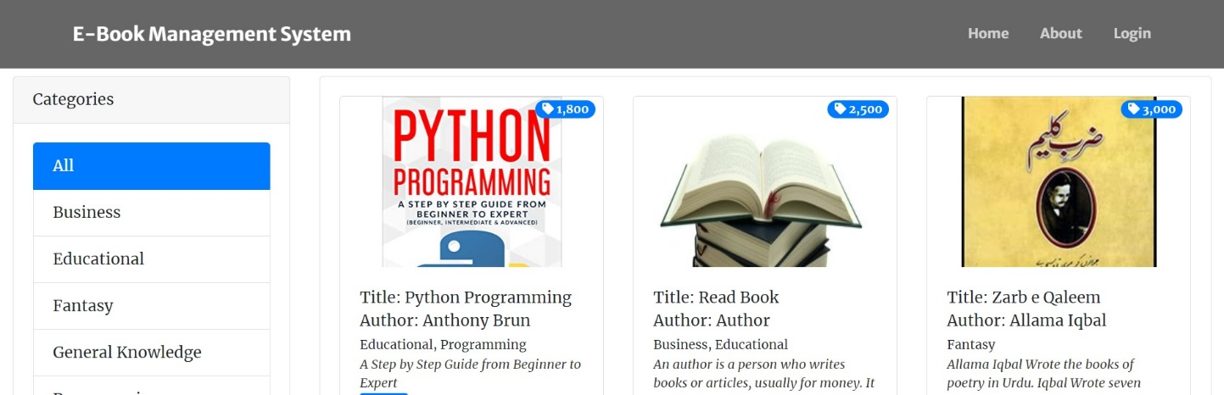

* The image shows the homepage of the Ebook Management Store website.
* The homepage features a search bar, a list of categories, and a list of featured ebooks.
* The search bar allows users to search for ebooks by title, author, or genre.
* The list of categories allows users to browse ebooks by genre.
* The list of featured ebooks showcases some of the most popular ebooks on the website.

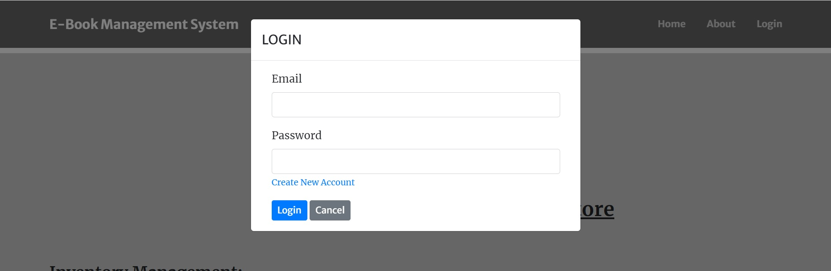

The image shows the login page for the Ebook Management Store website. The login page includes the following fields:

* Email address
* Password
* Login button
* Create new account link

To log in to the website, users must enter their email address and password in the appropriate fields and click the login button. If users do not have an account, they can click the create new account link to create an account.

Here are some additional details about the image

* The image shows the login page for the Ebook Management Store website.
* The login page is designed to be simple and easy to use.
* The login page is secure and uses HTTPS to protect user data.

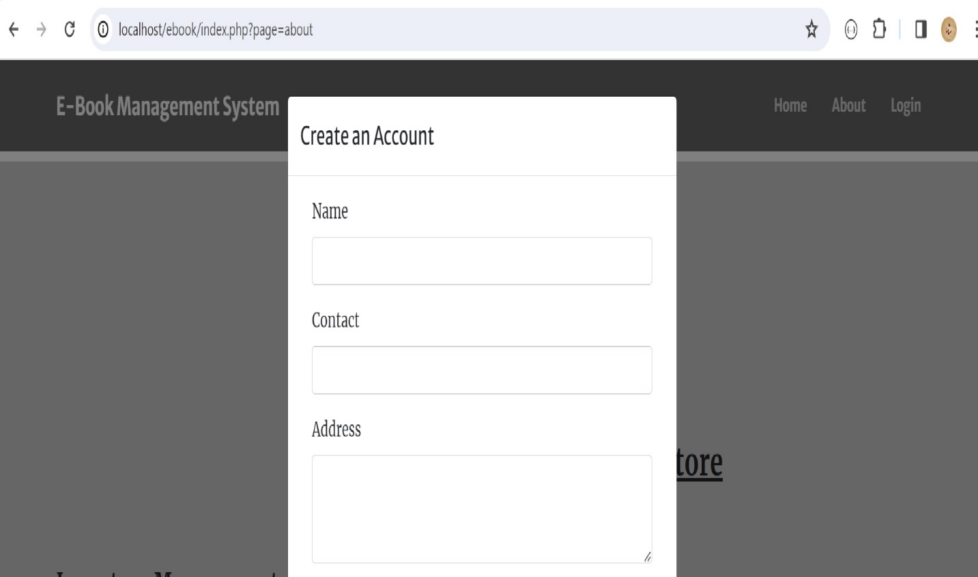

The image shows the "Create an Account" page for the Ebook Management Store website. The page includes the following fields:

* Name
* Email address
* Password
* Confirm password
* Create account button

To create an account, users must enter their name, email address, and password in the appropriate fields and click the create account button. Users must also confirm their password by entering it in the "Confirm password" field.

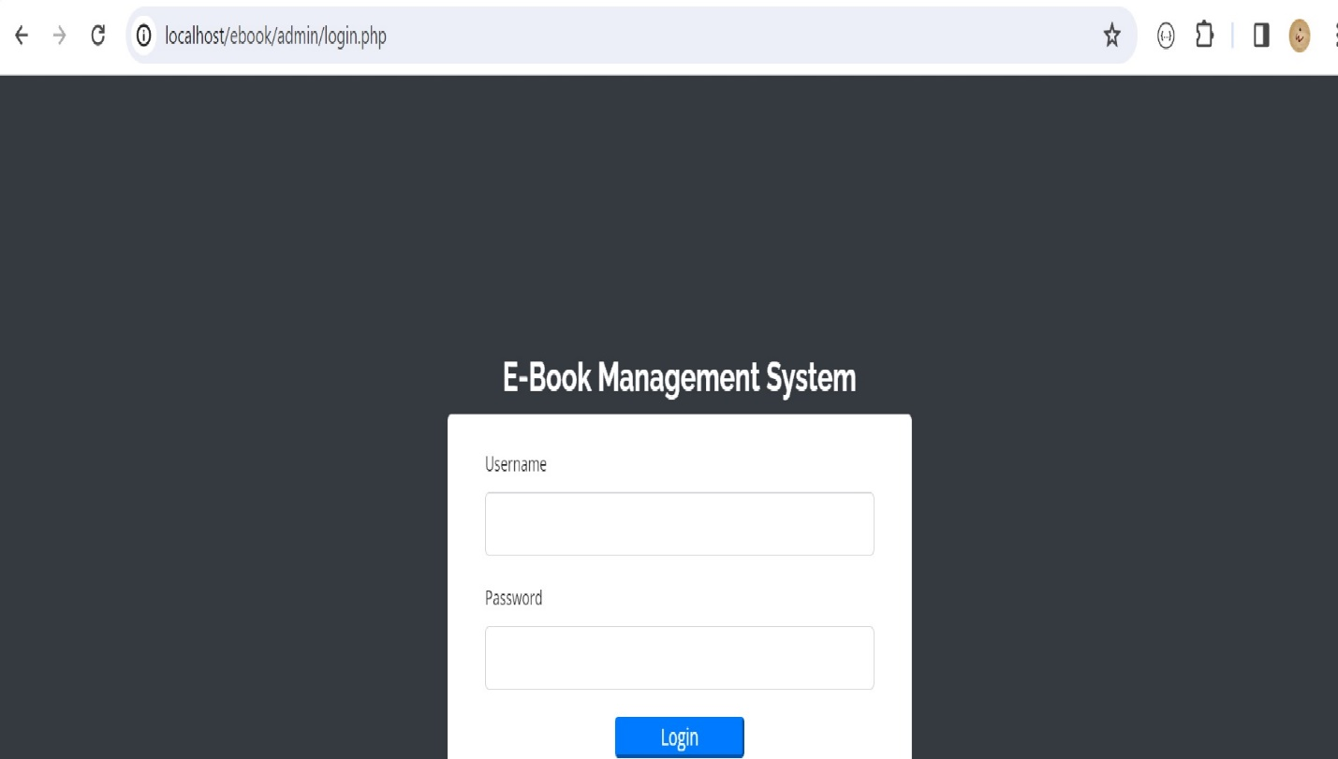

The image shows the "My Library" page for the Ebook Management Store website.

* A list of ebooks that the user has added to their library.
* A search bar that allows users to search for ebooks in their library.

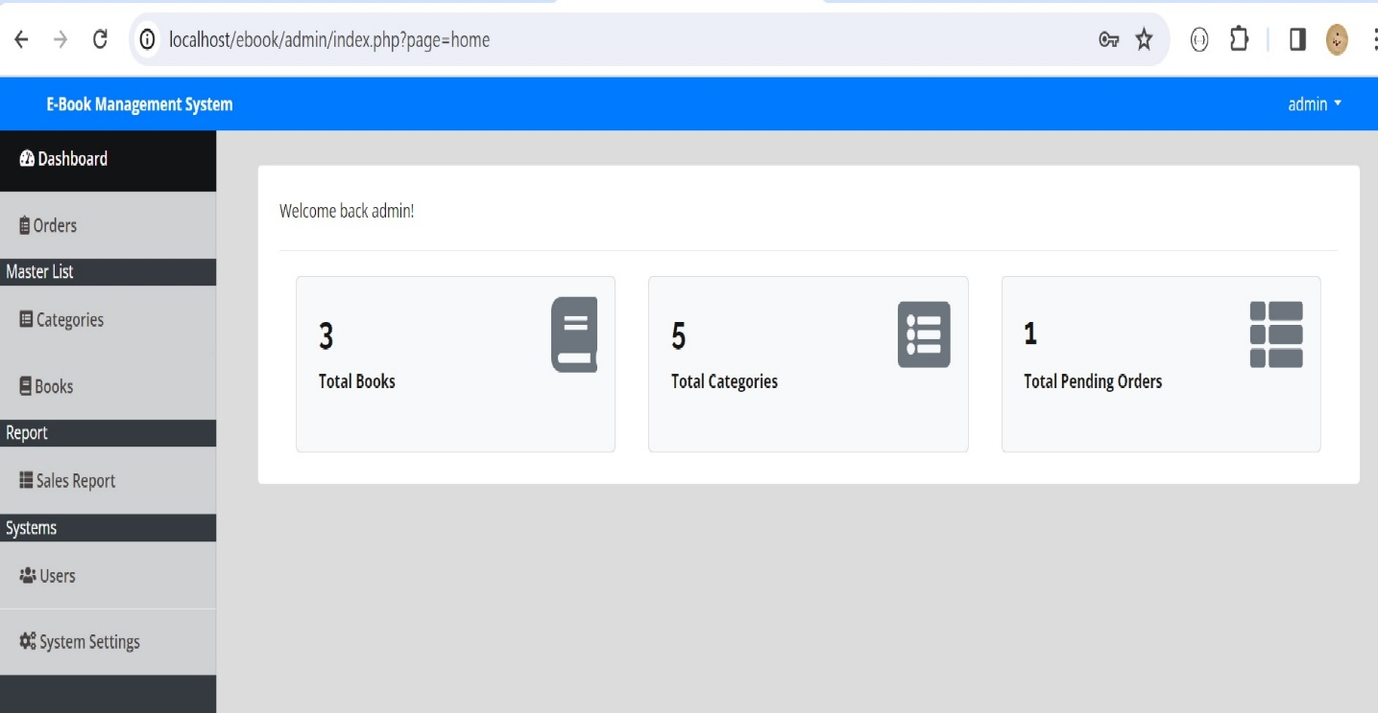

The image shows the "Ebook Details" page for the Ebook Management Store website.

* The title of the ebook.
* The author of the ebook.
* The genre of the ebook.
* The format of the ebook.
* The price of the ebook.
* A button to add the ebook to the cart.
* A button to read the ebook.

The "Ebook Details" page allows users to view the details of an ebook before purchasing it. Users can also add the ebook to their cart or read it directly from the website.

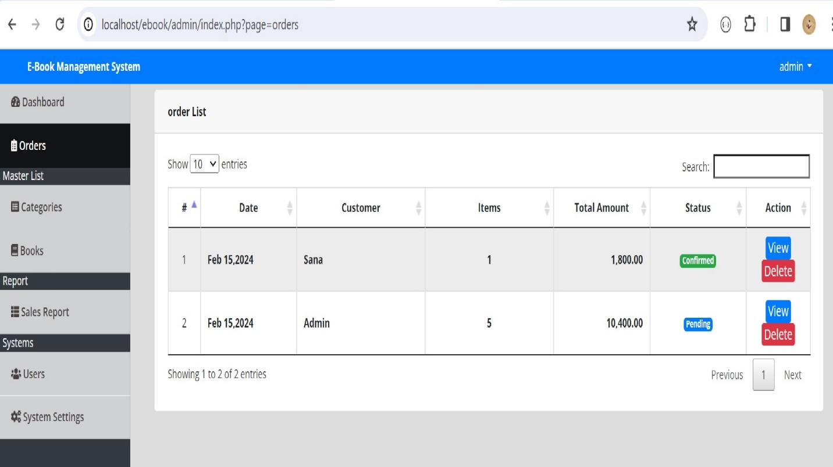

The image shows the "Cart" page for the Ebook Management Store website.

* A list of ebooks that the user has added to their cart.
* The total price of the ebooks in the cart.
* A button to checkout.

The "Cart" page allows users to view the ebooks that they have added to their cart and to checkout. Users can remove ebooks from their cart or add more ebooks to their cart. Users can also checkout and purchase the ebooks in their cart.

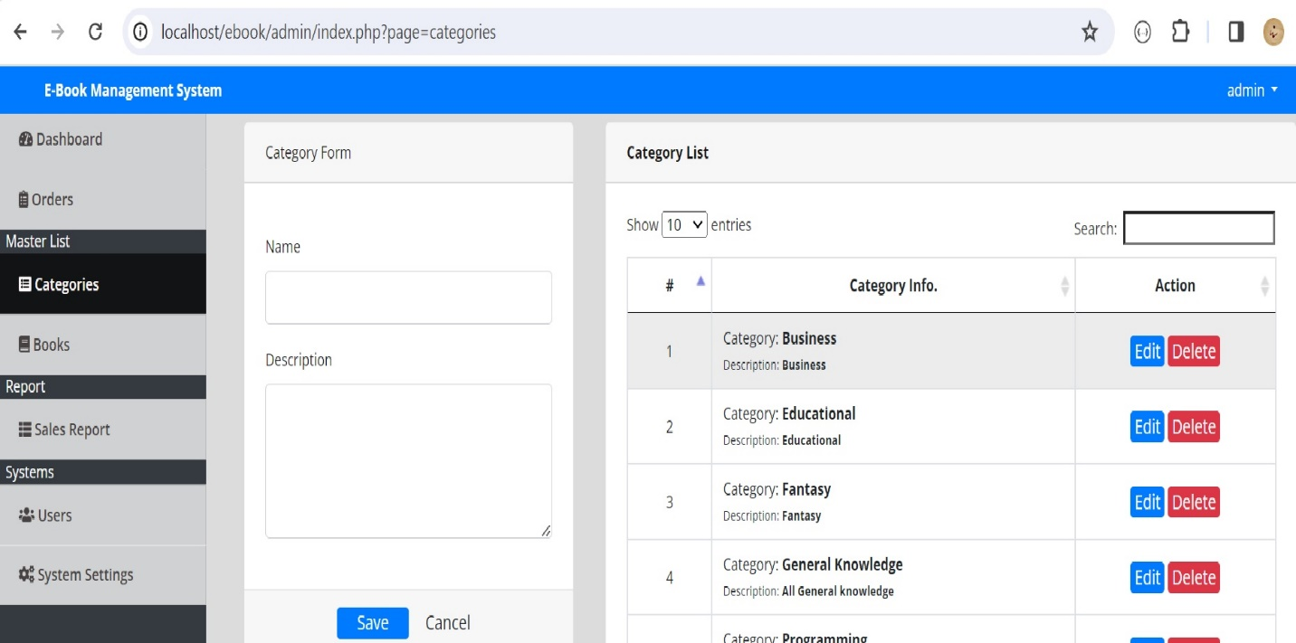

The image shows the dashboard of the Ebook Management Store website.

* A summary of the user's account, including the number of ebooks in their library, the number of ebooks they have purchased, and the amount of money they have spent.
* A list of recent activity, including the ebooks the user has added to their library, the ebooks they have purchased, and the ebooks they have read.
* A list of upcoming events, such as new ebook releases and sales.

The dashboard provides users with an overview of their account and activity on the Ebook Management Store website. Users can use the dashboard to view their account information, track their activity, and stay up-to-date on upcoming events.

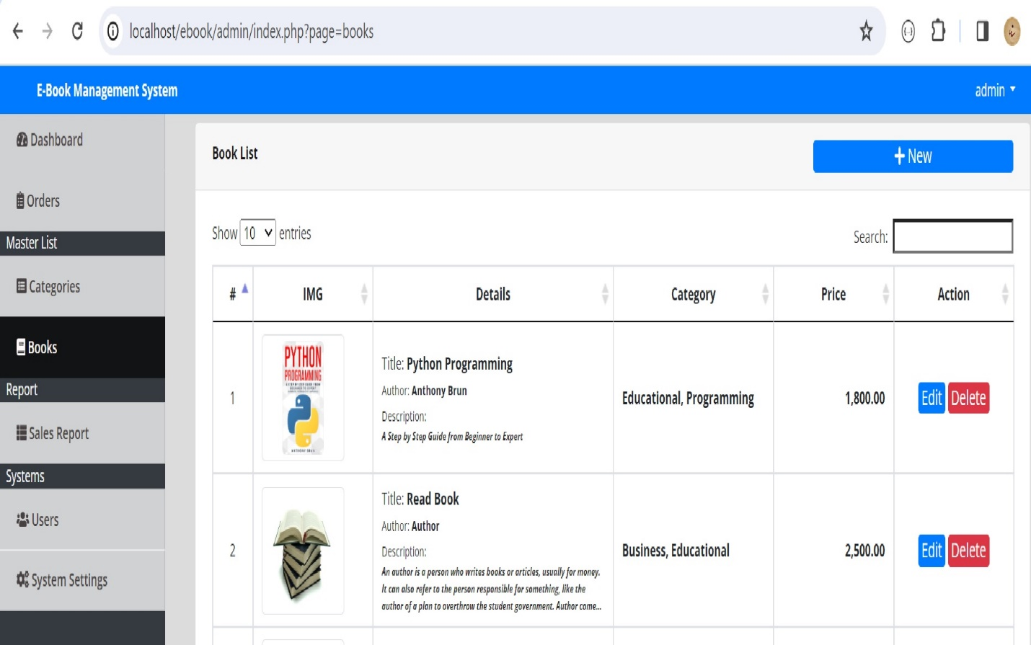

This is the search results page for the Ebook Management Store website.

* A search bar that allows users to search for ebooks.
* A list of ebooks that match the user's search query.
* A filter bar that allows users to filter ebooks by author, title, genre, or format.

The search results page allows users to find ebooks that they are interested in. Users can search for ebooks by author, title, genre, or format. Users can also filter and sort the search results to find the ebooks that they are looking for.

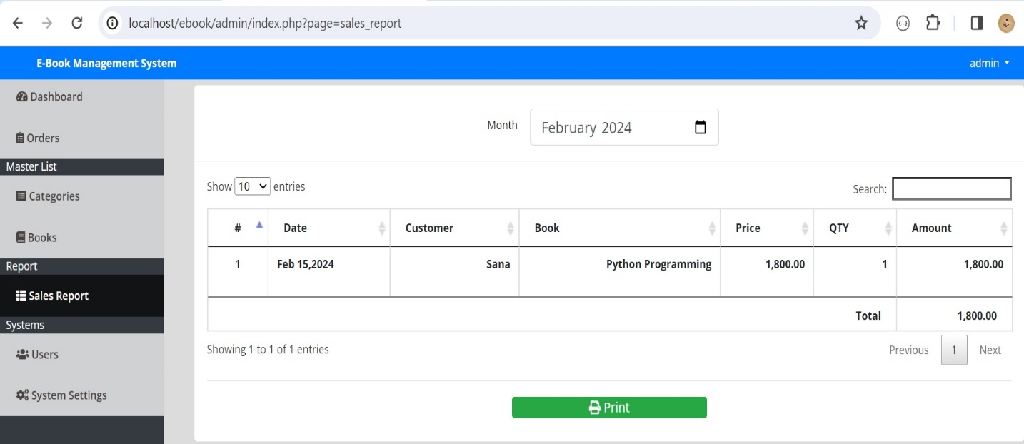

The image shows an example of a product listing page for an ebook management store. This type of page allows users to view information about an ebook and purchase it. The page typically includes the Date, Customer, Book, Price, Qty, Amount.

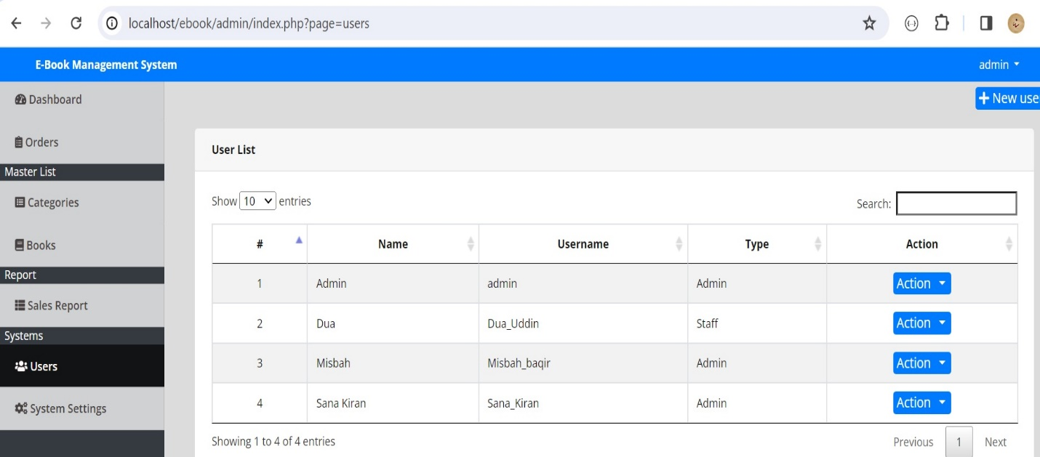

The image shows a user list page in an ebook management store's admin dashboard. It displays a table with the following columns:

* **#:** This column shows the user's ID number.
* **Name:** This column shows the user's full name.
* **Username:** This column shows the user's unique login name.
* **Type:** This column shows the user's account type, such as "Admin," "Staff," or "User."
* **Action:** This column shows buttons for performing actions on the user, such as "Edit," "Delete," or "View Details."

**Additional Information**

* The page title indicates that this is the "User List" page.
* The search bar at the top of the page allows users to search for specific users.
* The "Showing 1 to 4 of 4 entries" text indicates that there are four users in total, and the page is currently showing the first four.
* The "Previous" and "Next" buttons allow users to navigate through the list of users.

This image shows a well-organized and easy-to-use user list page in an ebook management store's admin dashboard. It provides all the necessary information about users and allows administrators to perform various actions on them.